**NAME:** KUSORO ADESOLA EUNICE

**MATRIC-NUMBER:** HCS/23/1087

**COURSE CODE**: COM 316

**LECTURER:** MR. J.L. AKINODE

**SOLUTION**

**QUESTION 1**

using System;

using System.Collections.Generic;

using System.Linq;

using System.Text;

using System.Threading.Tasks;

namespace ConsoleApplication39

{

public class Program

{

public static void Main(string[] args){

double [] arr = new double[3];

for(int k = 0; k < arr.Length; k++){

Console.Write("Enter the "+ (k + 1) +" number: ");

arr[k] = double.Parse(Console.ReadLine());

}

double greatest = 0;

for (int i = 0; i < arr.Length; i++){

if (arr[i] > greatest){

greatest = arr[i];

}

}

Console.WriteLine("The greater number = " + greatest);

Console.ReadLine();

}

}

}

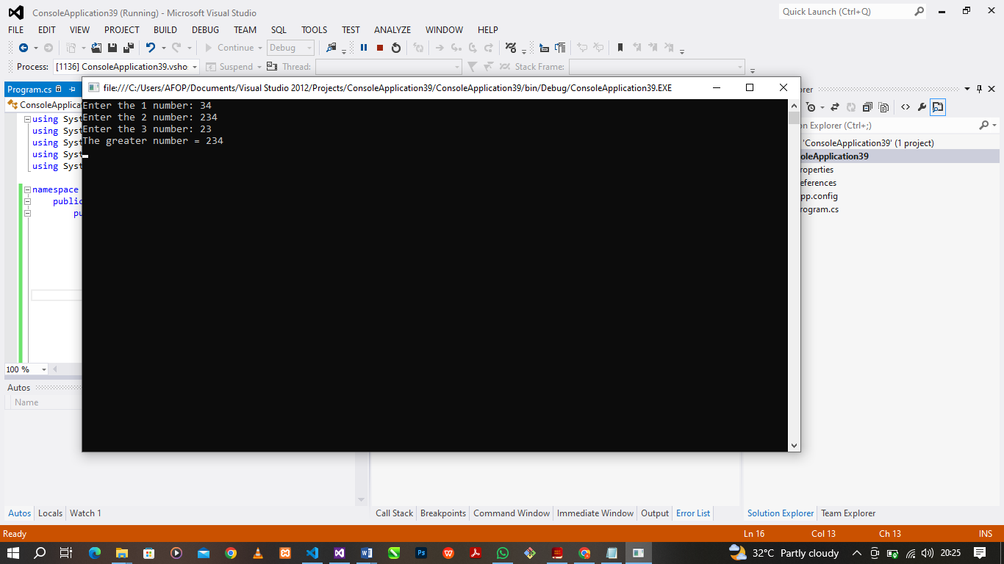

**QUESTION 2**

using System;

using System.Collections.Generic;

using System.Linq;

using System.Text;

using System.Threading.Tasks;

namespace ConsoleApplication39{

public class Program{

public static void Main(string[] args){

int [] arr = {23, 24, 12, 1, 90, 234, 120, 56, 13, 40};

int smallest = SmallIndex(arr, arr.Length);

Console.WriteLine("The smallest number = " + smallest);

Console.ReadLine();

}

public static int SmallIndex(int[] arr, int length){

int smallest = arr[0];

for (int i = 0; i < length; i++){

if (arr[i] < smallest){

smallest = arr[i];

}

}

return smallest;

}

}

}

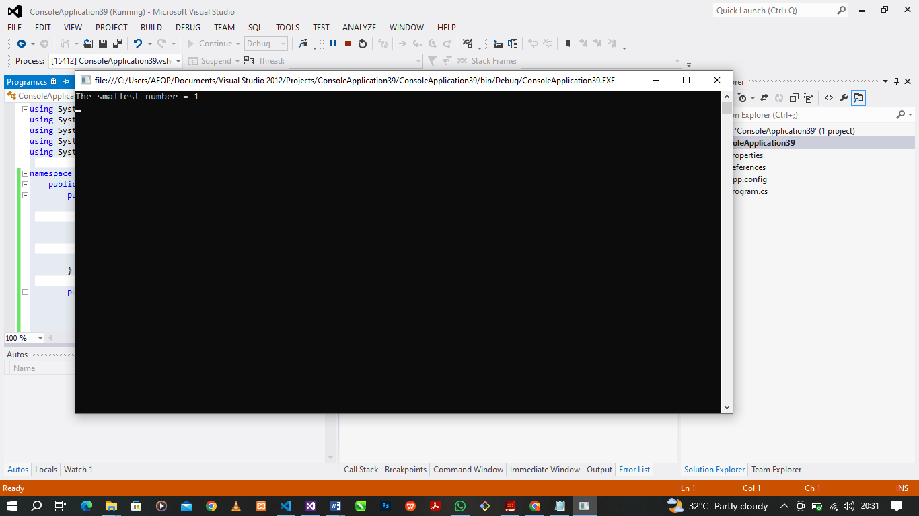

**QUESTION 3**

using System;

using System.Collections.Generic;

using System.Linq;

using System.Text;

using System.Threading.Tasks;

namespace ConsoleApplication39{

public class Program{

public static void Main(string[] args){

Console.Write("Enter any string message: ");

string message = Console.ReadLine();

char[] character_array = message.ToCharArray();

for (int i = 0; i < character_array.Length; i++)

{

character_array[i] = char.ToUpper(character_array[i]);

}

string backToString = new string(character_array);

Console.WriteLine("Formatted Text: " + backToString);

Console.ReadLine();

}

}

}

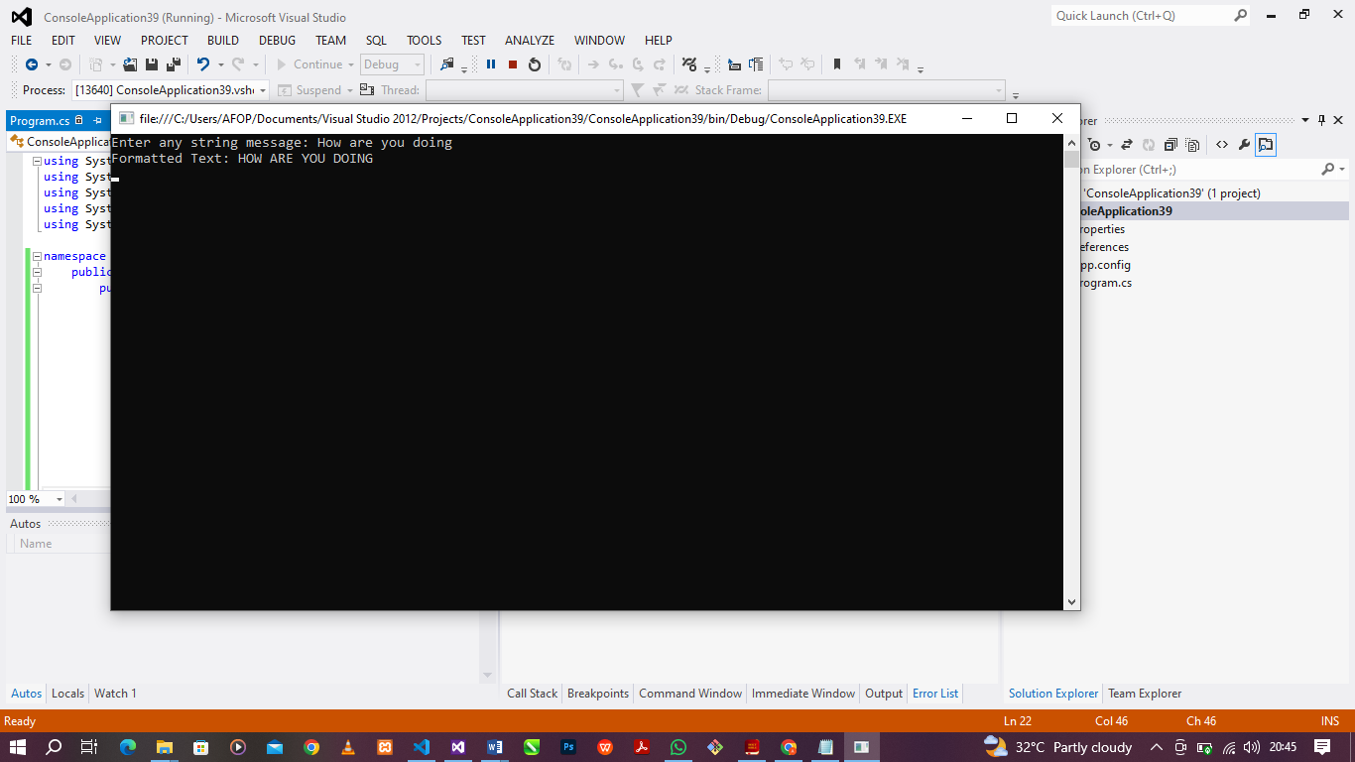

**QUESTION 4**

using System;

using System.Collections.Generic;

using System.Linq;

using System.Text;

using System.Threading.Tasks;

namespace ConsoleApplication39{

public class Program{

public static void Main(string[] args){

Console.Write("Please specify the number of rows: ");

int rows = int.Parse(Console.ReadLine());

Console.Write("Please specify the number of columns: ");

int columns = int.Parse(Console.ReadLine());

int[,] M = new int[rows, columns];

int[,] N = new int[rows, columns];

for (int i = 0; i < rows; i++)

{

for (int j = 0; j < columns; j++)

{

Console.Write("Enter value for M [" + i + "," + j + "]: ");

M[i, j] = int.Parse(Console.ReadLine());

}

}

for (int i = 0; i < rows; i++)

{

for (int j = 0; j < columns; j++)

{

Console.Write("Enter value for N [" + i + "," + j + "]: ");

N[i, j] = int.Parse(Console.ReadLine());

}

}

int[,] sum = new int[rows, columns];

for (int i = 0; i < rows; i++)

{

for (int j = 0; j < columns; j++)

{

sum[i, j] = M[i, j] + N[i, j];

}

}

Console.WriteLine("Sum Matrix:");

for (int i = 0; i < rows; i++)

{

for (int j = 0; j < columns; j++)

{

Console.Write(sum[i, j] + ", ");

}

Console.WriteLine();

}

Console.ReadLine();

}

}

}

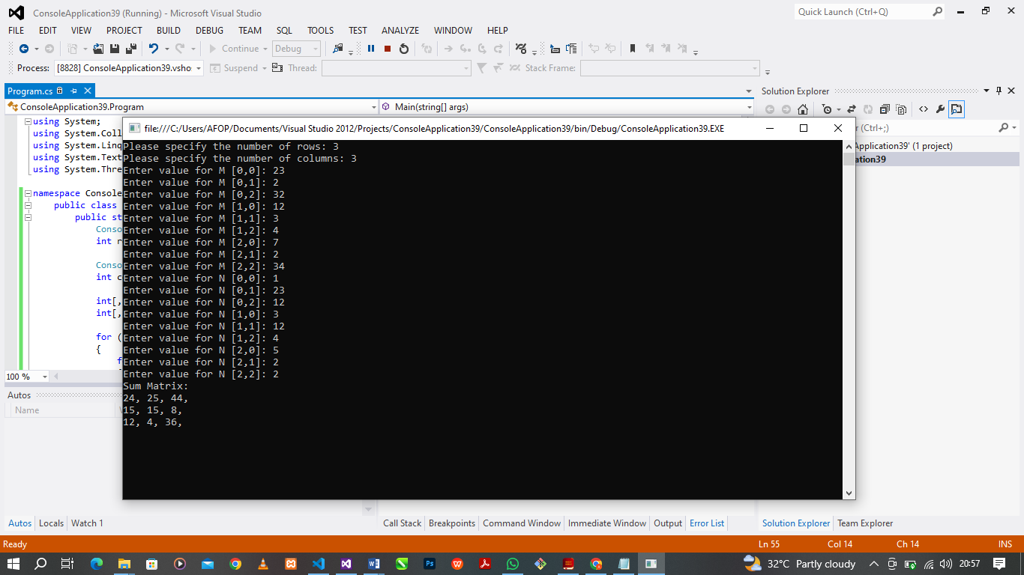

**QUESTION 5**

using System;

using System.Collections.Generic;

using System.Linq;

using System.Text;

using System.Threading.Tasks;

namespace ConsoleApplication39{

public class Program{

public static void Main(string[] args){

float[] alpha = new float[50];

for (int i = 0; i < alpha.Length; i++)

{

if (i < (alpha.Length / 2))

{

alpha[i] = i;

}

else

{

alpha[i] = i * i * i;

}

if ((i + 1) % 10 == 0 || i == alpha.Length - 1)

{

Console.WriteLine(alpha[i] + " ");

}

else

{

Console.Write(alpha[i] + " ");

}

}

Console.ReadLine();

}

}

}

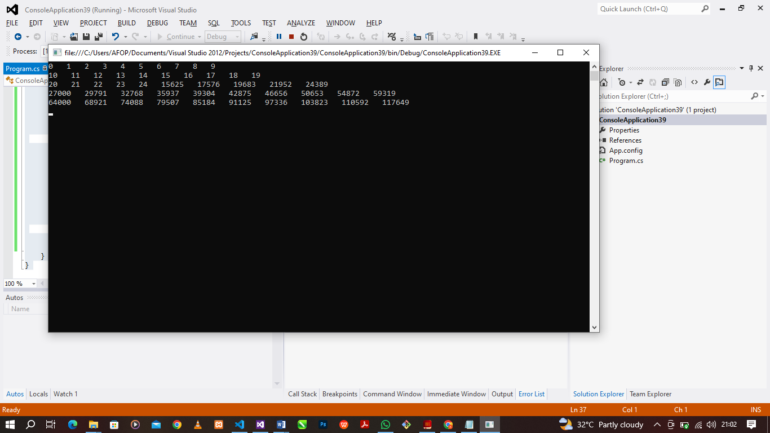

**QUESTION 6**

using System;

using System.Collections.Generic;

using System.Linq;

using System.Text;

using System.Threading.Tasks;

namespace ConsoleApplication39{

public class Program{

public static void Main(string[] args){

Console.Write("Enter any number: ");

double number = double.Parse(Console.ReadLine());

if (number < 0)

{

Console.WriteLine("The number(" + number + ") is a negative number");

}

else if (number == 0)

{

Console.WriteLine("The number(" + number + ") is equal to zero(0)");

}

else

{

Console.WriteLine("The number(" + number + ") is a positive number");

}

Console.ReadLine();

}

}

}

